
Da
Datasheet

Integrated Miniature RGB Laserchip “Neptune”
N03-H20-01_IND

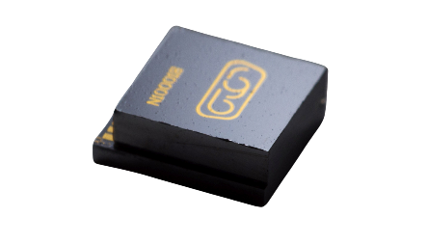

Description
Brilliance miniature RGB Neptune laserchip N03-H20-01_IND is the smallest, most robust and most scalable way to work with RGB lasers in projection applications. Neptune offers optimal performance of optical output properties combined with a very small form factor and flexible system integration. Neptune eliminates the cost and optical complexity of conventional laser combining solutions, enabling seamless integration into smart eyewear, automotive, and industrial applications while improving system reliability. This datasheet focuses on industrial applications.
with major reduction of the form factor and a more reliable construction.

Industrial Applications
- Fluorescence microscopy
- Metrology
- Scanning
- Display and illumination applications (in buildings and non-automotive vehicles)

Features
- Volume: 0.028 cc
- Weight: 50 mg
- Flat NA over wavelength (Ratio1:1 ± 5%)
- Ellipticity: 0.95 ± 5%
- Wavelengths: [639, 520, 450] nm
- Operation environmental temperature: - 10 ~+ 50°C
- Sealed package
- On-chip temperature sensor (NTC)

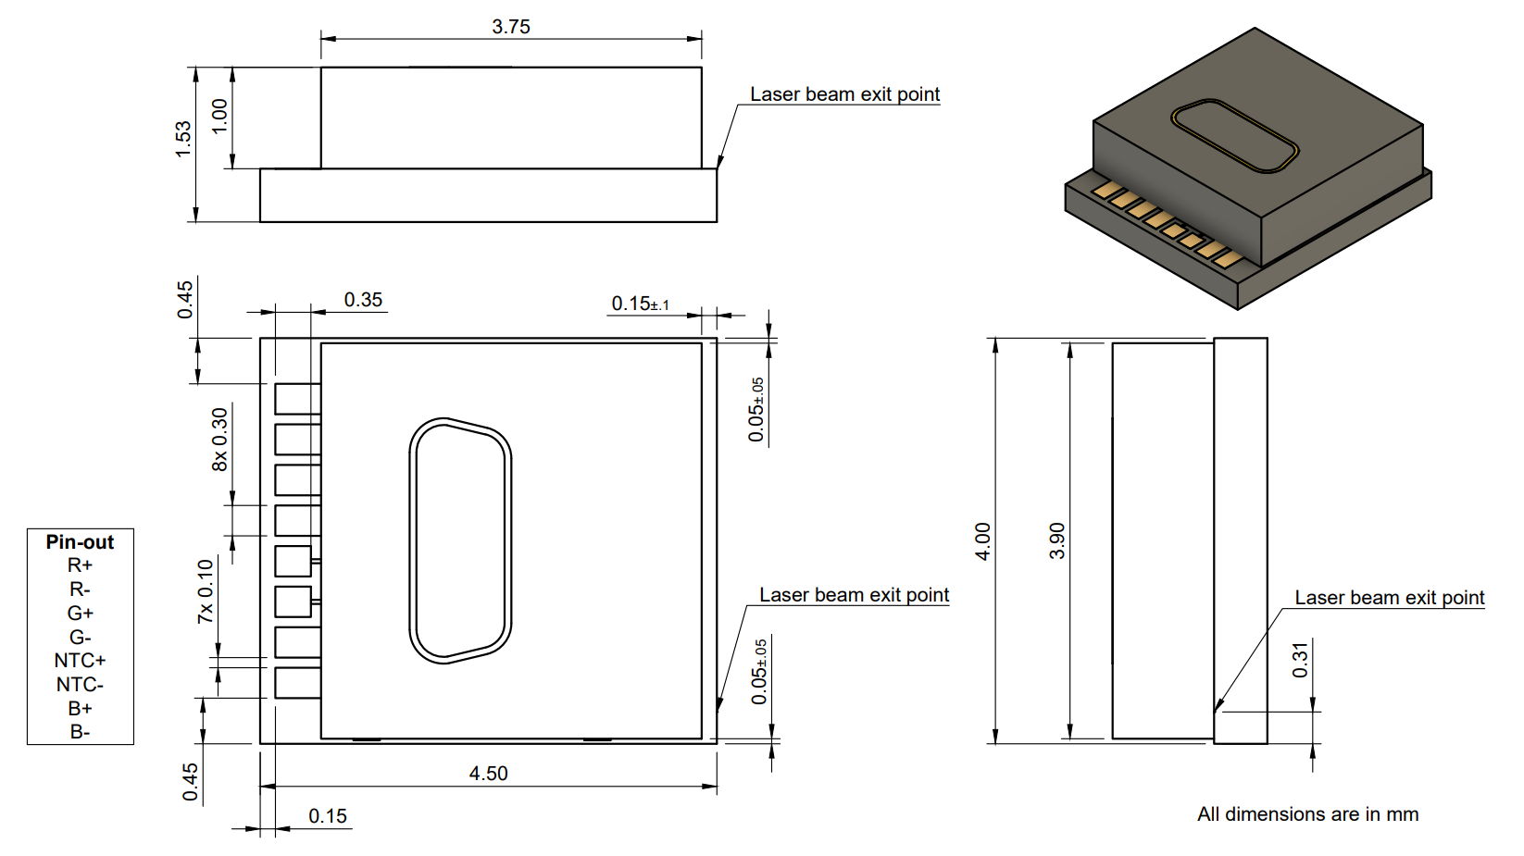

Characteristics (T_{c}=25°C)
Parameter | λ_{typ} | Symbol | Min | Typ | Max | Unit
Peak wavelength | 639 | λ | 634 | 639 | 644 | nm
Optical output power | 639 | P_{opt} | 40 | 95 | 150 | mW
Lumen output | 639 | P_{lum} | 4.6 | 10.6 | 16.8 | lm
Luminous efficacy | 639 | η_{lum} | - | 17.5 | - | lm/W
Mode field diameter | 639 | MFD | - | 3.7 | - | µm
Numerical aperture (x axis) | 639 | NA | 0.13 | 0.14 | 0.15 | -
Numerical aperture (y axis) | 639 | NA | 0.13 | 0.14 | 0.15 | -
Ellipticity of output | 639 | - | - | 0.99 | - | -
Beam divergence (1/e²) (x axis) | 639 | Θ‖ | 7.5 | 8.0 | 8.6 | °
Beam divergence (1/e²) (y axis) | 639 | Θ_{ꓕ} | 7.5 | 8.0 | 8.6 | °
Threshold current (T=25°C) | 639 | I_{th} | - | 50 | 60 | mA
Operating current (T=25°C) | 639 | I_{op} | - | 225 | 260 | mA
Operating voltage (T=25°C) | 639 | V_{op} | - | 2.7 | 3 | V
Polarization | 639 | P_{TE} | - | TE | - | -
Peak wavelength | 520 | λ | 510 | 520 | 530 | nm
Optical output power | 520 | P_{opt} | 30 | 64 | 98 | mW
Lumen output | 520 | P_{lum} | 13.5 | 28.7 | 44 | lm
Luminous efficacy | 520 | η_{lum} | - | 17.9 | - | lm/W
Mode field diameter | 520 | MFD | - | 3.5 | - | µm
Numerical aperture (x axis) | 520 | NA | 0.17 | 0.19 | 0.21 | -
Numerical aperture (y axis) | 520 | NA | 0.16 | 0.18 | 0.20
Ellipticity of output | 520 | - | - | 0.97 | - | -
Beam divergence (1/e²) (x axis) | 520 | Θ‖ | 9.8 | 11.0 | 12.1 | °
Beam divergence (1/e²) (y axis) | 520 | Θ_{ꓕ} | 9.2 | 10.4 | 11.5 | °
Threshold current (T=25°C) | 520 | I_{th} | - | 55 | 80 | mA
Operating current (T=25°C) | 520 | I_{op} |  | 255 | 295 | mA
Operating voltage (T=25°C) | 520 | V_{op} |  | 6.3 | 7.2 | V
Polarization | 520 | P_{TE} | - | TE | - | -
Peak wavelength | 450 | λ | 440 | 450 | 460 | nm
Optical output power | 450 | P_{Opt} | 30 | 53 | 75 | mW
Lumen output | 450 | P_{lum} | 0.7 | 1.2 | 1.8 | lm
Luminous efficacy | 450 | η_{lum} | - | 2.7 | - | lm/W
Mode field diameter | 450 | MFD | - | 2.2 | - | µm
Numerical aperture (x axis) | 450 | NA | 0.18 | 0.20 | 0.22
Numerical aperture (y axis) | 450 | NA | 0.17 | 0.19 | 0.21
Ellipticity of output | 450 | - | - | 0.93 | -
Beam divergence (1/e²) (x axis) | 450 | Θ‖ | 10.4 | 11.5 | 12.7
Beam divergence (1/e²) (y axis) | 450 | Θ_{ꓕ} | 9.8 | 11.0 | 12.1
Threshold current (T=25°C) | 450 | I_{th} | - | 12 | 30 | mA
Operating current (T=25°C) | 450 | I_{op} | - | 87 | 120 | mA
Operating voltage (T=25°C) | 450 | V_{op} | - | 5.2 | 6.5 | V
Polarization | 450 | P_{TE} | - | TE | - | -
Output pitch | N/A | p |  | 7 |  | µm
White output (D65) | N/A | η_{white} |  | 15 | 24 | lm/W
NTC: Mitsubishi Materials VH05-6D103FC | N/A | R |  | 10K |  | Ohm
Maximum Ratings (T_{c}=25°C)*
Disclaimer
N03-H20-01_IND is in pre-production stage. Upon finalization and freeze of design and process, some of the specified parameters may change or adjust. This datasheet will be updated accordingly, please check the website for updates.

Parameter | λ_{typ} | Symbol | Rating | Unit
LD max. current | 640 | I | 260 | mA
LD reverse voltage | 640 | V_{R} | 2 | V
LD max. current | 520 | I | 295 | mA
LD reverse voltage | 520 | V_{R} | 2 | V
LD max. current | 450 | I | 145 | mA
LD reverse voltage | 450 | V_{R} | 2 | V
Operating temperature | N/A | T_{Oper} | -10 to +50 | °C
Storage temperature | N/A | T_{Stor} | -40 to +85 | °C
*Ratings regarding the laser diode, excluding losses

Thermal Specifications
To achieve optimal performance, the laserchip temperature must be kept below 35 °C. In typical augmented reality applications, the laserchip operates using pulse-width modulation (PWM) at modulation frequencies in the hundreds of megahertz and a duty cycle of around 20%, for which a passive heat sink is recommended. It is essential to ensure a thermally efficient interface between the laserchip and the heat sink to maintain stable operation. For this interface, we recommend AuSn solder paste or silver paste with high thermal conductivity.

Demo kits
The RGB laserchip is available as a customized assembly mounted on a heatsink or flexible circuit board, for testing or demonstration purposes. Check our website for more information or send inquiries to info@brillliancergb.com

Customized Laser Photonics Integrated Circuits (PIC)
Custom versions with additional PIC functionality or adapted MFD and NA are available upon request. Please send inquiries to info@brillliancergb.com.
Warning
This product contains Class 3B laser diodes, which can cause eye injury or skin burns upon direct or specular reflection exposure. Proper laser safety procedures must be followed, including the use of appropriate laser safety eyewear rated for the emission wavelength(s). The device should be operated by trained personnel in a controlled environment with adequate safety interlocks and beam enclosures.

